CHAPTER 27
Case Study: Strategic Financial Planning in Long-Term Care Neil R. Dworkin, PhD
BACKGROUND
John Maxwell, CEO of Seabury Nursing Center, a not-for-profit long-term care organization located in suburban Connecticut, had just emerged from a board of directors meeting. He was contemplating the instructions he had received from the board’s executive committee to assess the financial feasibility of adding a home care program to the Center’s array of services.
Seabury’s current services consist of two levels of inpatient care, chronic care, and subacute units, and a senior citizens’ apartment complex financed in part by the Federal Department of Housing and Urban Development. In keeping with its mission, Seabury has a reputation of providing personalized, high-quality, and compassionate care across all levels of its continuum.
The CEO and his executive team agreed to meet the following week to plan the next steps.
FRAMEWORK OF THE BOARD’S MANDATE
At its last retreat, the board made clear that, reimbursement and payment systems notwithstanding, Seabury must establish realistic and achievable financial plans that are consistent with their strategic plans. Accordingly, three points relative to integrating strategic planning and financial planning should hold sway:
1. Both are the primary responsibility of the board
2. Strategic planning should precede financial planning
3. The board should play an active role in the financial planning process
Ultimately, every important investment decision involves three general principles:
1. Does it make sense financially?
2. Does it make sense operationally?
3. Does it make sense politically?
The board’s interest in a possible home initiative was guided by these stipulations, particularly as they relate to Seabury’s growth rate in assets and profitability objectives. As a result of the financial downturn, the organization is experiencing declining inpatient volumes, a deteriorating payer mix, and a higher cost of capital, all of which have the potential to weaken its liquidity position.
Taking the strategic service line path to a home care program would be less capital intensive and should appeal broadly to the significant baby boomer population residing in its service area, whose preference would undoubtedly be to be treated in their homes.
INDUSTRY PROFILE
When John Maxwell convened his executive team the following week, he had already decided to present an overview of the home health industry as gleaned by Seabury’s Planning Department. He prefaced his comments by drawing on recent research by the federal Agency for Healthcare Research and Quality that detailed why home health care in the 21st century is different from that which has existed in the past. He cited four reasons:
1. We’re living longer and more of us want to “age in place” with dignity.
2. We have more chronic, complex conditions.
3. We’re leaving the hospital earlier and thus need more intensive care.
4. Sophisticated medical technology has moved into our homes. Devices that were used only in medical offices are now in our living rooms and bedrooms. For example, home caregivers regularly manage dialysis treatments, infuse strong medications via central lines, and use computer-based equipment to monitor the health of loved ones.
The CEO presented a profile of national home care data as compiled by the National Association for Home Care and Hospice as follows:

- Approximately 12 million people in the United States require some form of home health care.
- More than 33,000 home healthcare providers exist today.
- Almost two-thirds (63.8%) of home healthcare recipients are women.
- More than two-thirds (69.1%) of home healthcare recipients are over age 65.
- Conditions requiring home health care most frequently include diabetes, heart failure, and chronic ulcer of the skin, osteoarthritis, and hypertension.
- Medicare is the largest single payer of home care services. In 2009, Medicare spending was approximately 41% of the total home healthcare and hospice expenditure.
According to the U.S. Census Bureau, he continued, in 2010 Connecticut’s population was 3,574,097 of which 14.4% were age 65 or older.3 A Visiting Nurse Association (VNA) analysis of revenue by payer source in the state indicated that 60% of revenue was derived from Medicare.
FEASIBILITY DETERMINATION
The CEO went on to explain that the feasibility determination would be based on initially setting the home care program’s capacity at 50 clients because that was the minimum 388389required for Certificate-of-Need (CON) approval in Connecticut. He distributed a model developed by healthcare finance expert William O. Cleverly (Figure 27–1), which presents the logic behind the integration of strategic and financial planning.
In essence, he said, financial planning is influenced by the definition of programs and services in consort with the mission and goals. The next step entails financial feasibility of the proposed homecare program. Among the components that should be considered in determining financial feasibility are the following:
• The configuration and cost of staff
• The prevailing Medicare and Medicaid reimbursement rates
Figure 27–1 Integration of Strategic and Financial Planning.
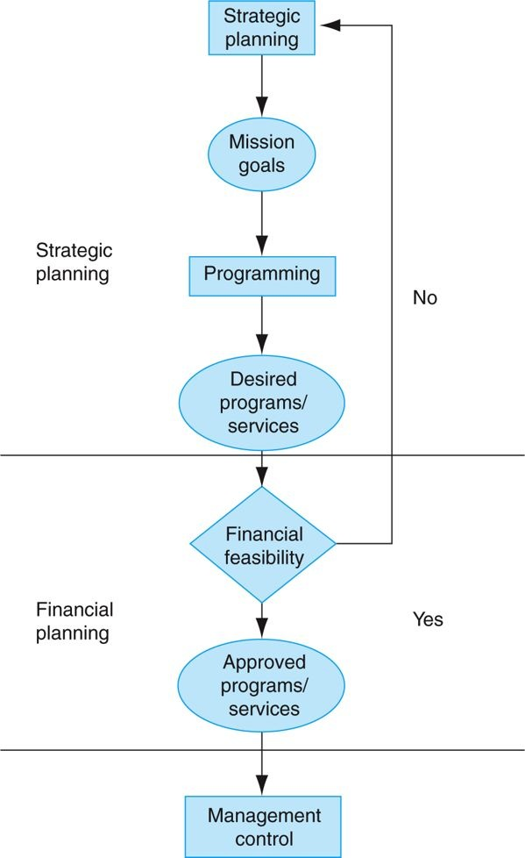

Reproduced from W.O. Cleverley, Essentials of Health Care Finance, 7th ed. (Sudbury, MA: Jones & Bartlett), 289.
• A projection of visit frequency by provider category based on the most prevalent clinical conditions
• The physical location of the program and its attendant costs (e.g., rent, new construction)
• A projection of cash flows
Direct care staff associated with the home care program includes:
• Medical Social Worker (MSW)
• Physical Therapist (PT)
• Home Health Aide (HHA)
• Registered Nurse (RN)
• Registered Dietitian (RD)
Maxwell indicated that it would be useful to create a scenario depicting a home health visit abstract incorporating prevailing Medicare and Medicaid reimbursement rates for a 70-year-old male with heart failure and no comorbidities in order to gain traction and project potential cash flow. As previously noted, heart failure is a condition frequently requiring home healthcare services. Productivity in the home is typically based on the average number of visits per day by provider category. The visit scenario is depicted in Table 27–1.
Table 27–1 A Home Health Visit Scenario
Service Visit Frequency Payer Rate Rate x 4.2* Medicare Medicaid
Cost Cost
Nursing (RN) 2x/month, every other week Mc $166.83 $700.69 $700.69
Medical Social Worker (MSW) Visits wkly for 4 wks MA $119.51 $501.94 $501.94
Physical Therapist (PT) 3x wkly for 2 wks Mc $103.22 $433.52 $433.52
Home Health Aide (HHA) Visits 4hrs MWF wkly for Mc $25.00 $1,260.00 $1,2600.00
60 day
Registered Dietitian (RD) 3x wkly for 1 wk MA $103.16 $309.48

Mc = Medicare
MA = Medicaid
* 4.2 = The state′s formula for the #wks/per month
Total monthly Medicaid budget = $826.95
Total monthly Medicare budget = $2,394.21
Figure 27–2 Seabury Nursing Center’s Home Healthcare-Related Organization Chart.

Once the board decides to move ahead with the home care program and it is approved by the state, implementation and ongoing operations becomes a management control issue (see the Cleverly model in Figure 27–1).
The CEO refers to a proposed table of organization as illustrated in Figure 27–2.
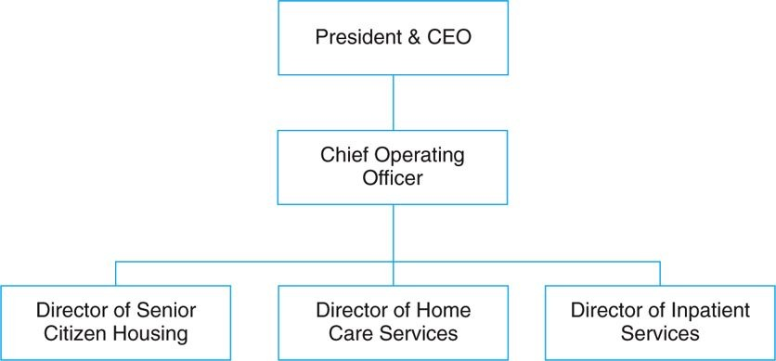
Given the paucity of other home care programs in its service area, Maxwell knows that Seabury is likely to be accorded a green light.
As he and his team reflect on this, the looming question will be where will the clients come from? He knows that likely referral sources will include Seabury’s subacute inpatient population and residents from its senior citizens’ apartment complex who are
“aging in place.” Other likely sources will be recently discharged patients from the region’s two community hospitals, both bereft of home care programs. A premium will be placed on effective case management, and direct marketing to the community will also be necessary.
NOTES
1. U.S. Department of Health and Human Services, “Human Factors Challenges in Home Health Care,” Research Activities, no. 376 (December 2011).
2. National Association for Home Care and Hospice, Basic Statistics about Home Care (Updated 2010).
3. Department of Commerce, U.S. Census Bureau, 2010 Demographic Profile.
4. Visiting Nurse Association, VNA Healthcare Annual Report (Hartford, CT: Hartford Healthcare, 2012).

CHAPTER 28
Case Study: Metropolis Health System
BACKGROUND
1. The Hospital System
Metropolis Health System (MHS) offers comprehensive healthcare services. It is a midsize taxing district hospital. Although MHS has the power to raise revenues through taxes, it has not done so for the past seven years.
2. The Area
MHS is located in the town of Metropolis, which has a population of 50,000. The town has a small college and a modest number of environmentally clean industries.
3. MHS Services
MHS has taken significant steps to reduce hospital stays. It has developed a comprehensive array of services that are accessible, cost-effective, and responsive to the community’s needs. These services are wellness oriented in that they strive for prevention rather than treatment. As a result of these steps, inpatient visits have increased overall by only 1,000 per year since 2008, whereas outpatient/same-day surgery visits have had an increase of over 50,000 per year.
A number of programmatic, service, and facility enhancements support this major transition in the community’s institutional health care. They are geared to provide the quality, convenience, affordability, and personal care that best suit the health needs of the people whom MHS serves.
• Rehabilitation and Wellness Center—for outpatient physical therapy and return-to-work services, plus cardiac and pulmonary rehabilitation, to get people back to a normal way of living.
• Home Health Services—bringing skilled care, therapy, and medical social services into the home; a comfortable and affordable alternative in longer-term care.
• Same-Day Surgery (SDS)—eliminating the need for an overnight stay. Since 1998, same-day surgery procedures have doubled at MHS.
• Skilled Nursing Facility—inpatient service to assist patients in returning more fully to an independent lifestyle.
• Community Health and Wellness—community health outreach programs that provide educational seminars on a variety of health issues, a diabetes education center, support services for patients with cancer, health awareness events, and a women’s health resource center.
• Occupational Health Services—helping to reduce workplace injury costs at over 100 area businesses through consultation on injury avoidance and work-specific rehabilitation services.
• Recovery Services—offering mental health services, including substance abuse programs and support groups, along with individual and family counseling.
4. MHS’s Plant
The central building for the hospital is in the center of a two-square-block area. A physicians’ office building is to the west. Two administrative offices, converted from former residences, are on one corner. The new ambulatory center, completed two years ago, has an L shape and sits on one corner of the western block. A laundry and maintenance building sits on the extreme back of the property. A four-story parking garage is located on the eastern back corner. An employee parking lot sits beside the laundry and maintenance building. Visitor parking lots fill the front eastern portion of the property. A helipad is on the extreme western edge of the property behind the physicians’ office building.
5. MHS Board of Trustees
Eight local community leaders who bring diverse skills to the board govern MHS. The trustees generously volunteer their time to plan the strategic direction of MHS, thus ensuring the system’s ability to provide quality comprehensive health care to the community.
6. MHS Management
A chief executive officer manages MHS. Seven senior vice presidents report to the CEO. MHS is organized into 23 major responsibility centers.
7. MHS Employees
All 500 team members employed by MHS are integral to achieving the high standards for which the system strives. The quality improvement program, reviewed and reestablished in 2010, is aimed at meeting client needs sooner, better, and more cost-effectively. Participants in the program are from all areas of the system.
8. MHS Physicians
The MHS medical staff is a key part of MHS’s ability to provide excellence in health care. Over 75 physicians cover more than 30 medical specialties. The high quality of their training and their commitment to the practice of medicine are great assets to the health of the community.
The physicians are very much a part of MHS’s drive for continual improvement on the quality of healthcare services offered in the community. MHS brings in medical experts from around the country to provide training in new techniques, made possible by MHS’s technologic advancements. MHS also ensures that physicians are offered seminars, symposiums, and continuing education programs that permit them to remain current with changes in the medical field.
The medical staff’s quality improvement program has begun a care path initiative to track effective means for diagnosis, treatment, and follow-up. This initiative will help avoid unnecessary or duplicate use of expensive medications or technologies.
9. MHS Foundation
Metropolis Health Foundation is presently being created to serve as the philanthropic arm of MHS. It will operate in a separate corporation governed by a board of 12 community leaders and supported by a 15-member special events board. The mission of the foundation will be to secure financial and nonfinancial support for realizing the MHS vision of providing comprehensive health care for the community.
Funds donated by individuals, businesses, foundations, and organizations will be designated for a variety of purposes at MHS, including the operation of specific departments, community outreach programs, continuing education for employees, endowment, equipment, and capital improvements.
10. MHS Volunteer Auxiliary
There are 500 volunteers who provide over 60,000 hours of service to MHS each year. These men and women assist in virtually every part of the system’s operations. They also conduct community programs on behalf of MHS.
The auxiliary funds its programs and makes financial contributions to MHS through money it raises on renting televisions and vending gifts and other items at the hospital. In the past, its donations to MHS have generally been designated for medical equipment purchases. The auxiliary has given $250,000 over the last five years.
11. Planning the Future for MHS
The MHS has identified five areas of desired service and programmatic enhancement in its five-year strategic plan:
I. Ambulatory Services
II. Physical Medicine and Rehabilitative Services
III. Cardiovascular Services
IV. Oncology Services
V. Community Health Services
MHS has set out to answer the most critical health needs that are specific to its community. Over the next five years, the MHS strategic plan will continue a tradition of quality, community-oriented health care to meet future demands.
12. Financing the Future
MHS has established a corporate depreciation fund. The fund’s purpose is to ease the financial burden of replacing fixed assets. Presently, it has almost $2 million for needed equipment and renovations.

